**HTML**

1.**Write the HTML5 code required to create a form that looks like the following screen design. Only write the FORM element and**

**Its contents** (5 marks)

(you do not need to include an entire web page, and you do not need to include any JavaScript in your solution).

•For the email field, make sure that the user can only enter a valid email address.

•The user can only select one day (either Friday, Saturday, or Sunday)

•The form elements are grouped together with the caption 'Options'

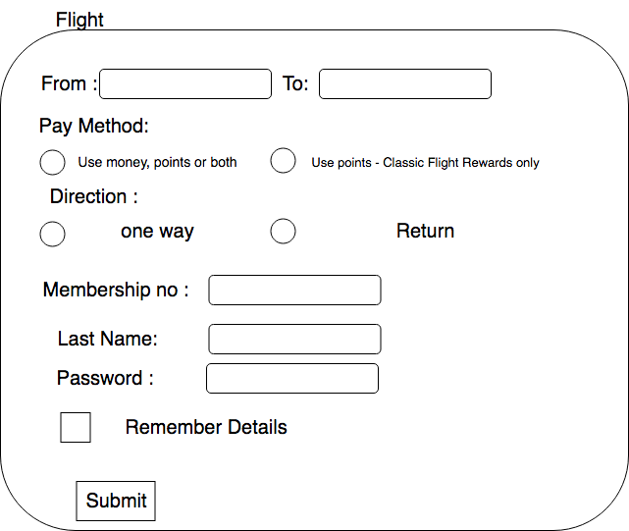

**CSS**

Question 1 (5 marks):

Write down the CSS style definition required to style the li element so that it has:

1. a correct CSS selector
2. a border set to 5px and black color
3. a 20px padding on all sides
4. a font color set to red
5. a font family set to Arial

Question 2 (5 marks):

Write down the CSS style definition required to style a class attributes which name is flights

so that it has:

1. a correct CSS selector
2. a background color set to blue
3. a font size set to 40px;
4. a margin 50px on all sides
5. a text color set to white

Question 3 (5 marks):

Write down the CSS style definition required to style h1 tag so that it has:

1. a correct CSS selector
2. a text decoration set to underline
3. a text align set to center
4. a font family set to sans-serif
5. a border set to 3px and black color

Question 4 (5 marks):

Write down the CSS style definition required to style an ID named as navbar so that it has:

1. a correct CSS selector
2. a width of 100%
3. a height of 600px
4. a background image set to the file “cat.png”
5. a display attribute set to fixed-top

Question 5 (5 marks):

Write down the CSS style definition required to style a class attributes which name is shopping-cart-items so that it has:

1. a correct CSS selector
2. a red text
3. a font size set to 1.5em
4. a background color set to gold
5. a border set to 2px and black color

Question 6 (5 marks):

Write down the CSS style definition required to style an id attributes which name is my-favourite-item so that it has:

1. a correct CSS selector
2. a background color set to red
3. a margin top set to 20px
4. a border radius set to 20px
5. a border set to 2px and black color

**JavaScript**

Q1. Complete the missing JavaScript code to make change the background color of a text field to yellow when the user clicks on the text field.

Here is the partially completed code (some code has been omitted as indicated by the ellipses "..."). The space marked with the arrow is where the missing JavaScript belongs. Write the missing JavaScript on the next page.

<!doctype html>

<html>

<head>

<meta charset="utf-8" />

<title> </title>

<script>

... 🡨-------

</script>

<style></style>

</head>

<body>

<input type="text" id="inputField" onclick="makeYellow()"/>

</body>

</html>

Q2. Complete the missing JavaScript code to make change the text color of a paragraph to blue when the user clicks on the button.

Here is the partially completed code (some code has been omitted as indicated by the ellipses "..."). The space marked with the arrow is where the missing JavaScript belongs. Write the missing JavaScript on the next page.

<!doctype html>

<html>

<head>

<meta charset="utf-8" />

<title> </title>

<script>

... 🡨-------

</script>

<style></style>

</head>

<body>

<p id=”msg”> Hello World!!!</p>

<button onclick="convertText ()">Click Me</button>

</body>

</html>

Q3. Complete the missing JavaScript code to make change the text color of a paragraph to yellow when the user clicks on the button.

Here is the partially completed code (some code has been omitted as indicated by the ellipses "..."). The space marked with the arrow is where the missing JavaScript belongs. Write the missing JavaScript on the next page.

<!doctype html>

<html>

<head>

<meta charset="utf-8" />

<title> </title>

<script>

... 🡨-------

</script>

<style></style>

</head>

<body>

<h1 id=”title”> Shopping-list </h1>

<button onclick="changeTitleColor ()">Click Me</button>

</body>

</html>

Q4. Complete the missing JavaScript code to make change to the navbar set background color to blue when the user clicks on the button.

Here is the partially completed code (some code has been omitted as indicated by the ellipses "..."). The space marked with the arrow is where the missing JavaScript belongs. Write the missing JavaScript on the next page.

<!doctype html>

<html>

<head>

<meta charset="utf-8" />

<title> </title>

<script>

... 🡨-------

</script>

<style></style>

</head>

<body>

<div id=”navbar”>

<li> MyWebsite </li>

<li>Contact Us</li>

<li>About US</li>

<li>Find US</li>

</div>

<button onclick="changeNavbarColor ()">Click Me</button>

</body>

</html>

**PHP**

**Q1. How to get the data from this form to welcome.php file**

<form action="welcome.php" method="post">  
Name: <input type="text" name="name"><br>  
E-mail: <input type="email" name="email"><br>  
<input type="submit">  
</form>

**Q2. How to get the data from this form to welcome_get.php file**

<form action="welcome_get.php" method="get">  
Username: <input type="text" name="username"><br>  
Password: <input type="password" name="email"><br>  
<input type="submit">  
</form>

**Q3. How to get the data from this form to result.php file**

<form action="result.php" method="get">  
Name: <input type="text" name="name"><br>  
Age: <input type="text" name="age"><br>  
<input type="submit">  
</form>

**Q3. How to get the data from this form to register.php file**

<form action="register.php" method="post">  
FirstName: <input type="text" name="f_name"><br>

LastName: <input type="text" name="l_name"><br>  
Age: <input type="text" name="age"><br>

E-mail: <input type="email" name="email"><br>  
Address: <input type="email" name="address"><br>

Passport: <input type="email" name="passport"><br>  
<input type="submit">  
</form>